Student Name:
Unit:
Prof:
Date:

Indigenous Art Analysis- Nicholas Galanin
Brief Biography
Nicholas Galanin is one of the spectacular, Native American artists who continues to make a mark in contemporary art industry. Born in 1979 in Sitka Alaska, Galanin developed an interest in visual art early in life (Rasmuson Foundation). He has a mixed Tlingit/Aleut ancestry and throughout his work, he has expressed in interest in promoting Native American culture, heritage and identity. As a multi-disciplinary and impressively talented artist, Galanin has created art works that appeal to native culture, such as countering the stereotypes about indigenous history and culture. He is an artist that offers diverse expertise in sculpture, painting performance, as well as video which often touch on cultural representation of the Native American people. In its scale and purpose, Galanin’s work is global and appeals to diverse people. Through this, the artists shows pride in not only his cultural presentation about Americans and humanity at large (Besaw et al., 169).
Concerning inspiration, Galanin’s exposure to art came early in his life where his father, Dave Galanin, and uncle, Will Burkhart, taught him jewelry, carving and working with light metals in Sitka. They both were had mastery in art that appealed to the Tlingit and Unangax way of life. As a toddler he would watch his father do the art work in the workshop and was very intrigued. Growing up, he would ask lots of questions about art and given countless opportunities to try out (Galanin). For Galanins, art was a family trait as George Benson, Nicholas grandfather, was involved in several art projects for his community (Galanin). Nicholas Galanin also understood how art was important not just to his father but his community. He acknowledged that art was language, tool and a beautiful way to explain his heritage, an aspect that was not easy to pass across to the audience.
Then, Galanin’s passion and diligence in art took him to London Guildhall University where he graduated with Bachelor’s Degree in Fine Arts as well as Honors in Jewelry Design and Silversmithing. He would further pursue his studies where he acquired a graduate degree in Indigenous Visual Arts at Massey University in New Zealand in 2004 (Besaw et al., 169). Inspired by a rich heritage of Tlingit, he forged his creativity in numerous projects. His works range from a modified an AR-15 rifle to carved totem poles, impressive wood carving, modern petroglyphs and abstract paintings. He merged conventional cultural art with more contemporary themes mainly centering on indigenous history and identity. Galanin’s first art auction was Untitled which went up at Heffel Online in 2018. His artworks have been exhibited in several museums including, Alaska’s Anchorage Museum, the Whitney Museum of American Art, Santa Fe’s The Museum of Contemporary Native Arts and North Miami’s Museum of Contemporary Art (Galanin). His diverse works of art have attracted more than four dozen exhibitions both in North America and beyond. Today he is a renowned indigenous artist who has been widely featured in the media, including articles in Art Asia Pacific and the Observer.
Galanin’s Art Analysis
As mentioned above, Galanin was inspired by his native Tlingit culture and makes art that appeal to cultural discourse of his community, both in the past and present. The following discussion samples some of his art works and their critical analysis at they relate to US history and culture.
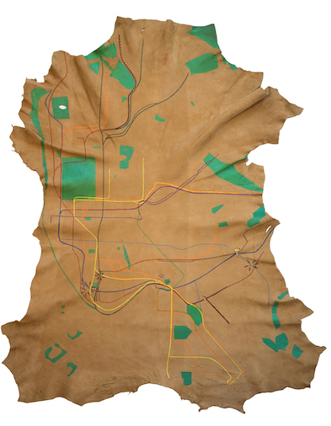
Figure 1: Nicholas Galanin, Land Swipe, 2019, acrylic on deer hide 44 x 36 inches (111.8 x 91.4 cm), Peter Blum Gallery, New York
This piece primary outlines that green spaces as well as the underground transport road in Manhattan used by the Native Americans in past decades (Battaglia). In his interpretation, Galanin used the art to decry the forceful removal of indigenous people in their lands by the white settlers. One looking at the art reminds the challenges and difficulties that first nations faced including resource theft and forceful seizure. Truly, the images and patterns takes one back to the unfair treatment of the indigenous people in the last centuries and how their modern suffering is evidence of historical injustices.
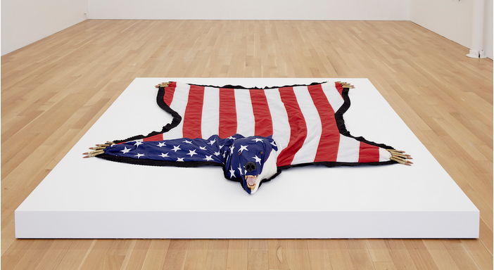
Figure 2: Nicholas Galanin, The American Dream Is Alie and Well, 2012, US Flag, felt, .50 Cal Ammunition, Foam, Gold Leaf, Plastic
Here, the bear, donned in American flag colors with claws of ammunition and alluding to fakeness of the American dreams depict the colonial practice of ill-treatment of the first nations (Battaglia). The indigenous people were despised, disrespected and often killed just as game animals are hunted for trophy-keeping. The white supremacist government murdered not just the native people but also sought to wipe out their spirituality and cultural beliefs. The art is about the conservation of the indigenous culture and a reflection on how the American dream is still elusive to them.
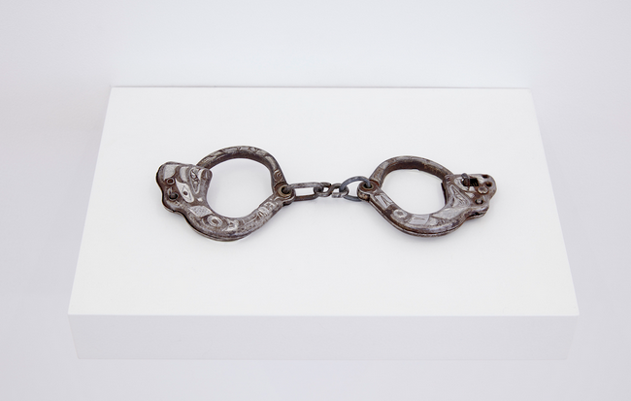
Figure 3: Nicholas Galanin, Indian Children’s Bracelet. (2014-8), Hand-engraved iron, 3 × 7 1/2 × 1/2 in7.6 × 19.1 × 1.3, Portland Art Museum.
This is a heart-touching piece of art that speaks about the state of indigenous children during the colonial times. The iron handcuffs allude to mistreatment of the children. It included exposure to torture, family separation and even killing of the indigenous children as white settlers took over land and resources. The bracelet is therefore much more than a beautiful hand-worn attire but a reminder of how history judges indigenous children.
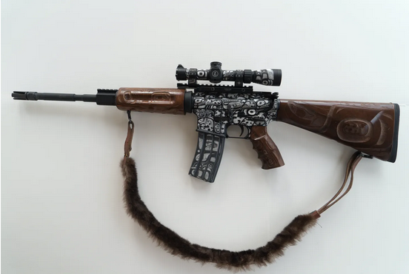
Figure 4: Nicholas Galanin, Haa Aaní (Our Land), Hand Engraved and Carved AR15 w/ soft case 16" M4 Barrel, 5.56 nato, 1/9, M-16, Leupold Mark AR MOD 1 1.5-4x20mm P5 Dial Riflescope, Matte Black, Duplex Reticle, Fancy Grade Walnut Wood AR-15 furniture, Hand sewn Sea Otter strap, 2013

Here, Galanin uses the modified gun as a form of rebellion as a result of the pain and suffering endured by the first nations at the mercy of the white settlers (Galanin). The takeover of their lands and drawing up of colonial border deeply hurt those who have lived long before the settlers arrived. The gun is a sign of resistance not just to the creation of the border but also to the supremacy of the settler culture as seen by the animal-skin gun belt that signify traditionalism of the first nations.
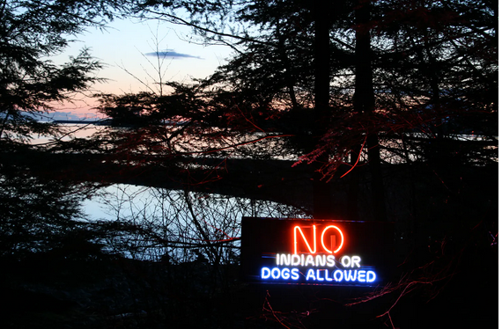
Figure 5: Nicholas Galanin, Where will we go?, 2008, Neon, photography, Pratt Museum

This last piece of art portrays the segregation of the indigenous people upon the coming of the white settlers. By making the comparison of the Indians to the dogs, the art refers to the low social status that settlers accorded the native people, worth as dogs in their face. Just like other pieces of art above, here, Galanin invokes the nostalgia about not just the physical borders but also the mental ones that form the basis for discrimination of native people as backward and less civilized. This piece of art is a reminder of equality and diversity and the need of the American society to step up and make the nation all-inclusive for all.

Works Cited
Battaglia, Andy. Ancient to the Future: Nicholas Galanin Aims to Change How Indigenous Art Is Understood. Art news. 13 February 2020. Web. 8 October 8, 2020. <https://www.artnews.com/art-news/artists/nicholas-galanin-peter-blum-gallery-1202677789/>
Besaw, Mindy N., et al. Art for a New Understanding: Native Voices, 1950s to Now. 1 ed. University of Arkansas Press, 2018. Project MUSE muse.jhu.edu/book/62365.
Galanin, Nicholas. Out of Line: Nicholas Galanin Rejects the Traditional/Contemporary Binary. Walker Art. 26 March 2018. Web. 8 October 8, 2020. <https://walkerart.org/magazine/nicholas-galanin-indigenous-art-contemporary-traditional>
Rasmuson Foundation. Nicholas Galanin. 2020. Web. 8 October 8, 2020. <https://www.rasmuson.org/enjoy-cat/art-collection/nicholas-galanin/>

